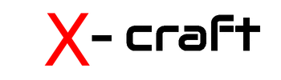

Unmanned Seacraft

**The Company :** X-craft are fundamentally problem solvers. We are a New Zealand company that designs, develops and tests robotic air and sea craft specialising in system development with many of our clients seeking custom solutions for difficult problems or conducting field operations in the most challenging environments. For over a decade X-craft has been at the forefront of robotic system technology in New Zealand.

**The Craft :** X-craft operates two main seacraft, the small 2.2 metre Taniwha vessel and the 5.8 metre Proteus. These have been specific tools for specific operational roles.

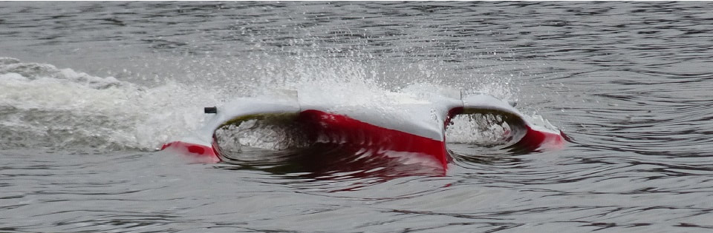 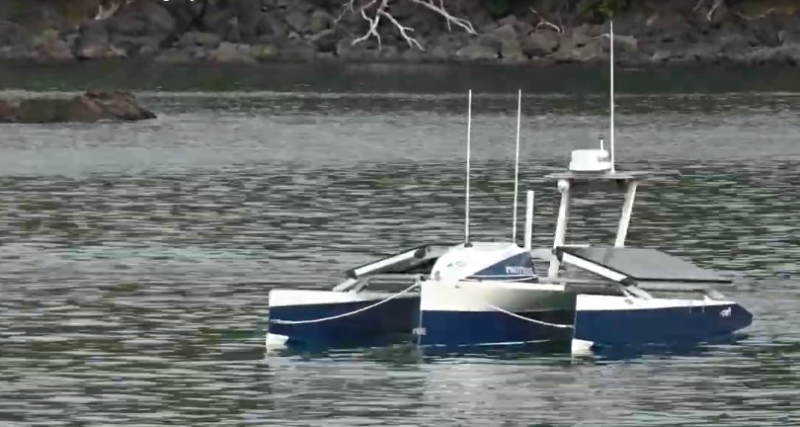

There are currently two new prototype craft under construction. One, is best described as a self powered sensor buoy, designed and constructed for extreme endurance data collection in defined locations. The second is an extreme endurance, extreme weather craft designed for mobile data collection operations over large areas.

**The Team :** X-craft has developed a specific team of specialists for maritime system development.

|  |  |  |  |
| --- | --- | --- | --- |
|  |  |  |  |
| Philip Solaris,  CEO of X-craft with over a decade in the robotic craft sector | Stephan Knapp,  Electrical Engineer with a passion for creative and innovative projects. Bringing autonomous craft such as Proteus to reality through specialty in UAV systems, embedded software systems and embedded design. |  |  |